Contentss

1. Introduction: 1

1.1. Purpose: 1

1.2. Scope: 1

1.2.1. Specific goals: 1

1.3. Overview 1

2. Users 2

2.1. Who are users? 2

2.2. Use cases and diagrams: 2

3. System: 3

3.1. Development Environment and Target Environment: 3

3.2. Functional Requirements: 4

3.2.1. Issues: 4

3.2.2. Major functions: 4

3.2.3. Major classes identified 4

3.2.3.1. UML class diagram 5

3.2.3.2. Sequence diagram 5

3.2.4 Minor System Functions 6

3.3. User Interface 6

3.4. NON-FUNCTIONAL REQUIREMENTS 6

3.4.1 Management 7

3.4.2 Technical 7

3.4.3. Security 7

4. Oher Deliverables required 7

5. Glossary 7

6. References: 7

**1.Introduction**

Steganography deals with hiding of messages in using different medium like audio, video and images. In some cases, a key can be generated and used to hide the message. By this technique, only sender and receiver are able to know the existence of the message.

**1.1 Purpose**

This requirements specification document elucidates the purpose of steganographic encryption tool. Furthermore, it completely depicts what the tool will do and how it will be relied upon to perform. The purpose behind this tool is to hide a message in an image, covermedium, which is encrypted using a secret key, stegokey, and decryption can be done using only that key.

**1.2 Scope**

Now a days sending data securely is one of the main task. The main objective is to create a tool that can be used to hide data inside a 24-bit color image and this tool uses an image degradation approach to effectively hide the message. The tool allows the user to upload the key, message and image which then the message is embedded in the image and this image with message in it is called stegomedium. So in order to decrypt that message we need to use the secret key.

The specific goal is to create a tool that helps in sending secret messages without knowing to the third party.

**1.3 Overview**

The following document is arranged as follows. Section 2 describes the users of the system and shows Unified Modeling Language use case diagrams. Section 3 specifies the target and development environment and it also discusses about functional requirements, user interface specification and non-functional requirements of the system. Functional requirements deal with issues, major functions, major classes and Requirements Specification Document for steganography. Whereas, non-functional requirements include constraints such as management, technical, and performance of the system. User interface specification shows a mockup screen of the application. Other deliverables required for this project are mentioned in Section 4. The Glossary of this document is present in section 5 and the references are listed under Section 6.

**2. Users**

**2.1 Who are users?**

The users are everyone who desires to send the data securely.

**2.2 Use cases and Diagrams**

A use case diagram at its simplest is a representation of a user's interaction with the system that shows the relationship between the user and the different use cases in which the user is involved.

**3. System**

The system describes the minimum hardware and software requirements.

**Hardware Requirements**

* Dual core processor
* Memory of 1 GB RAM
* Hard Disk of 40 GB

**Software:**

* Windows
* Microsoft project
* Java

**3.1 Functional Requirements**

**3.1.1 Issues:**

* The message hidden in an image has to reach the authorized person securely, since nobody except the sender and the receiver knows the existence of the message.
* The key exchange between the sender and the receiver must be secured.
* There is a limit to the size of the data in which we can embed information into.

**3.1.2 Major functions:**

* Data hiding: It can hide any data within a cover file. In this mode we can hide the data in an image or we can extract the data from the image.
* Watermarking: watermarking files with an invisible signature. It can be used to detect unauthorized file signature. In this you can watermark or verify images with your signature. First we need to generate a signature file, and then it can be used to watermark images or verify the same later.

**3.1.3 Major classes identified:**

Get_image

Plain text

Cipher text

Data_hiding

Watermarking

**3.1.4 Minor system functions:**

This software should enable the user to get the image and the message that has to be loaded into an image. Encryption key is maintained so that only authorized person can decode that message.

**3.2 User interface specification:**

The graphical user interface of this application is similar to the below figures.

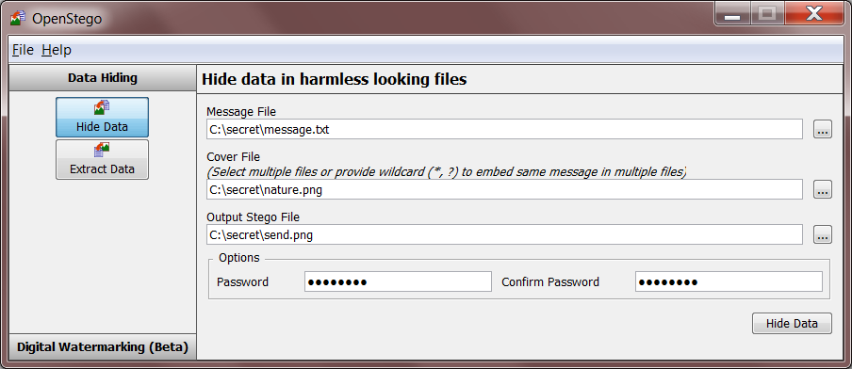

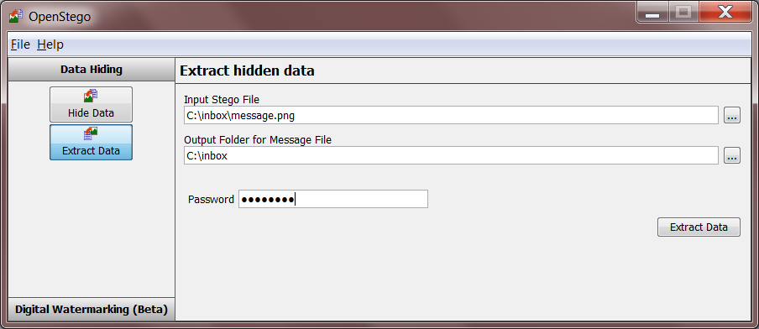

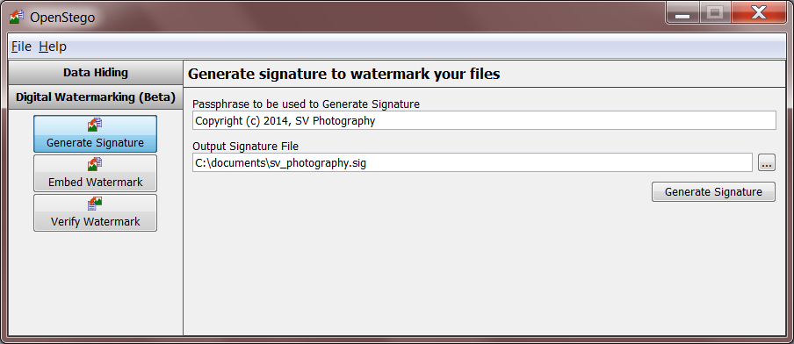

**3.3 Non Functional Requirements:**

**3.3.1 Management:**

Due to this being a student-developed project, there will be no cost incurred on our part. Project must be developed during the spring semester and completed by May 2016. Periodic reviews and testing of the listed functions should be conducted to ensure that the project meets the requirements.

**3.3.2 Technical:**

This software must run on a standard Windows 7 system. Likewise, the development environment will also be Windows 7 and it is to be written in some java development environment. To make this software highly reliable, testing will be performed several times during the development of the project. Testing will include unit testing, integrated testing, interface testing, and other related testing. The efficiency of disk space and memory will be specified later in development phase. The prototype should also be user-friendly, so as to impress those to whom it is demonstrated.

**3.3.3 Performance**

The user should be able to send the secret message in such a way that the receiver can understand the message.

**3.3.4 System Evolution/Maintenance**

This application should be developed in a way as to make it easier for future developers to maintain or enhance the application.

**4. Other Deliverables**

At the end of the project (May 2016), a project plan, requirements specification document, test plan, test report, prototype, final report and user manual outline will be delivered to the customer.

**5. Glossary**

Covermedium:

Covermedium is the file in which we will hide the hiddendata, which may also be encrypted using the stegokey. Covermedium are typically image or audio files.

Covertext:

A large and harmless looking data which is used as container for plaintext or ciphertext. This can be a picture, sound or text

Stegokey:

Stego key is the secret key used to encrypt the message, without the key the hidden message cannot be retrieved.

Stegomedium:

The data generated after embedding the plain text or cipher text into the covertext.

**6. References**

[1]. Stringfellow, Dr.Catherine.

[2]. Sommerville I.,“Software Engineering 9th edition”.

[3]. Pressman Roger S., “Software Engineering – A Practitioner’s Approach 7th edition”.